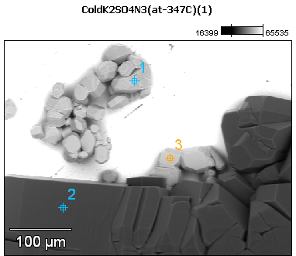

Image Name: ColdK2SO4N3(at-347C)(1)

Image Resolution: 512 by 384

Image Pixel Size: 0.92 µm

Acc. Voltage: 12.0 kV

Magnification: 270

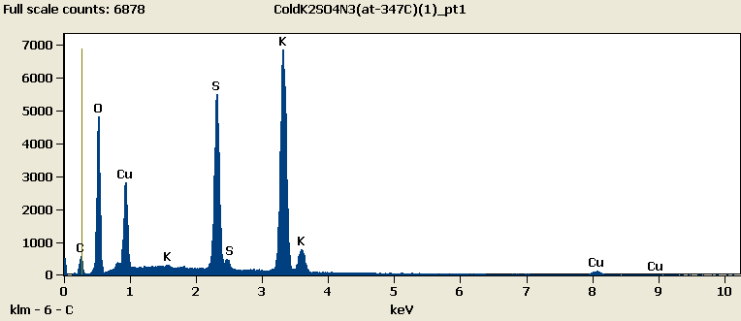

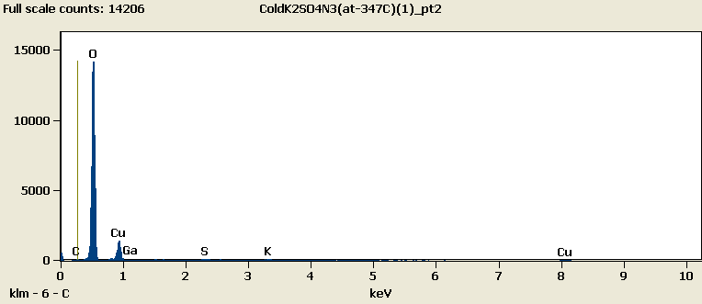

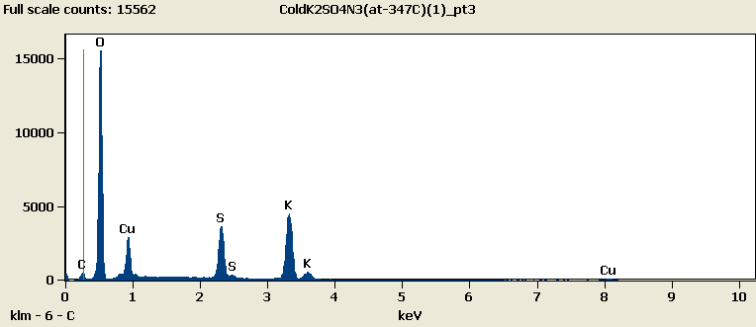

Note: Last point was covered by ice at the time of the scan

Weight %

|  |  |  |  |  |  |  |
| --- | --- | --- | --- | --- | --- | --- |
|  | ***C-K*** | ***O-K*** | ***S-K*** | ***K-K*** | ***Cu-L*** | ***Ga-L*** |
| ***ColdK2SO4N3(at-347C)(1)_pt1*** | 4.62 | 25.80 | 17.37 | 36.65 | 15.55 |  |
| ***ColdK2SO4N3(at-347C)(1)_pt2*** | 0.52 | 70.26 | 0.55 | 0.81 | 25.97 | 1.90 |
| ***ColdK2SO4N3(at-347C)(1)_pt3*** | 2.46 | 50.59 | 10.48 | 21.09 | 15.37 |  |

Weight % Error (+/- 1 Sigma)

|  |  |  |  |  |  |  |
| --- | --- | --- | --- | --- | --- | --- |
|  | ***C-K*** | ***O-K*** | ***S-K*** | ***K-K*** | ***Cu-L*** | ***Ga-L*** |
| ***ColdK2SO4N3(at-347C)(1)_pt1*** | ±0.16 | ±0.20 | ±0.12 | ±0.22 | ±0.17 |  |
| ***ColdK2SO4N3(at-347C)(1)_pt2*** | ±0.11 | ±0.27 | ±0.05 | ±0.07 | ±0.39 | ±0.36 |
| ***ColdK2SO4N3(at-347C)(1)_pt3*** | ±0.13 | ±0.21 | ±0.09 | ±0.16 | ±0.17 |  |

# Cations

|  |  |  |  |  |  |  |
| --- | --- | --- | --- | --- | --- | --- |
|  | ***C-K*** | ***O-K*** | ***S-K*** | ***K-K*** | ***Cu-L*** | ***Ga-L*** |
| ***ColdK2SO4N3(at-347C)(1)_pt1*** | 0.00 | 0.00 | 0.00 | 0.00 | 0.00 |  |
| ***ColdK2SO4N3(at-347C)(1)_pt2*** | 0.00 | 0.00 | 0.00 | 0.00 | 0.00 | 0.00 |
| ***ColdK2SO4N3(at-347C)(1)_pt3*** | 0.00 | 0.00 | 0.00 | 0.00 | 0.00 |  |